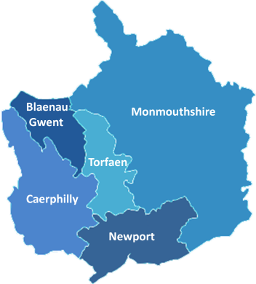 | The Greater Gwent (Torfaen) Pension Fund  administered by Torfaen County Borough Council | LOCAL GOVERNMENT PENSION SCHEME
Change of Circumstances Form
Surname |  |  |  |  |  |  |  |  |  |  |  |  |  |  | Forename(s)
Pay Number |  |  |  |  |  |  |  |  |  |  |  | Post Ref |  |  |  |  |  |  |  |  |  |  |  | N.I. Number
Election to pay reduced contributions for a temporary period (join the 50/50 section)
Date joined main section |  |  |  |  |  |  |  |  |  |  |  |  |  |  |  |  |  | Date Joined 50/50 section
Election to re-join the main section from the 50/50 section
Date Joined 50/50 section |  |  |  |  |  |  |  |  |  |  |  |  |  |  |  |  |  | Date re-joined main section
Change of post reference (e.g. post name or post number)
Changed from |  |  |  |  |  |  |  |  |  |  |  |  | Changed to |  |  |  |  |  |  |  |  |  |  |  |  | Date of change
Change of pension contribution rate
Old % rate |  |  |  |  |  |  |  |  |  |  |  |  | New % rate |  |  |  |  |  |  |  |  |  |  |  |  | Date of change
Change of Contractual Hours (per week) – you must include % of FT if member works Term Time
New hours |  |  |  |  |  |  |  |  | FT hours |  |  |  |  |  |  |  |  | % of FT |  |  |  |  |  |  |  | Date of change
Previous hours |  |  |  |  |  |  |  |  | FT hours |  |  |  |  |  |  |  |  | % of FT |  |  |  |  |  |  |  | Date of change
Change of Contractual Weeks (per year) – you must include % of FT if member works Term Time
New weeks |  |  |  |  |  |  |  |  |  |  |  | % of FT |  |  |  |  |  |  |  |  |  |  |  |  | Date of change
Previous weeks |  |  |  |  |  |  |  |  |  |  |  | % of FT |  |  |  |  |  |  |  |  |  |  |  |  | Date of change
Break in Pensionable Service
From |  |  |  |  |  |  |  |  |  | To |  |  |  |  |  |  |  |  |  | Reason
Change of Name - a copy of the Marriage or Deed Poll Certificate must be attached
New name |  |  |  |  |  |  |  |  |  |  |  |  |  |  |  |  |  |  |  |  |  |  |  |  | Date of change
Change of Address
 |  |  |  |  |  |  |  |  |  |  |  |  |  |  |  |  |  |  |  |  |  |  |  |  | Post Code
Change of personal email address
New personal email address |  |  |  |  |  |  |  |  |  |  | @
If your organisation has already made an arrangement with the Fund to send some of the required Change of Circumstances information to us electronically, you don’t need to duplicate your notification of that Change of Circumstance on a hardcopy form
Scheme Employer Certification
I am an authorised signatory of the Scheme Employer, named below, for sending instruction to the Greater Gwent (Torfaen) Pension Fund (the Fund) and hereby certify that the information provided on this form is correct. I confirm that we will indemnify the Fund against any costs or claims which may arise if any information provided on this form is not correct
 | Name |  |  |  |  |  |  |  |  |  |  |  |  |  |  |  |  |  | Position
 | Email Address |  |  |  |  |  |  |  |  |  |  |  |  |  |  |  |  |  | Phone Number
 | Scheme Employer
 | Signature |  |  |  |  |  |  |  |  |  |  |  |  |  |  |  |  |  | Date

